UNITED STATES
SECURITIES AND EXCHANGE COMMISSION
Washington, D.C. 20549
FORM 8-K
CURRENT REPORT
PURSUANT TO SECTION 13 OR 15(d)
OF THE SECURITIES EXCHANGE ACT OF 1934
Date of Report (Date of earliest event reported): July 14, 2026
HOLLEY INC.
(Exact name of registrant as specified in its charter)
Delaware |  |  | 001-39599 |  |  | 87-1727560
(State or other jurisdiction  of incorporation) |  |  | (Commission  File Number) |  |  | (IRS Employer  Identification No.)
1A Burton Hills Blvd, Suite 240, Nashville, TN |  |  |  |  |  | 37215
(Address of principal executive offices) |  |  |  |  |  | (Zip Code)
(270) 782-2900
(Registrant’s telephone number, including area code)
(Former name or former address, if changed since last report)
Check the appropriate box below if the Form 8-K is intended to simultaneously satisfy the filing obligation of the registrant under any of the following provisions:
o |  |  | Written communications pursuant to Rule 425 under the Securities Act (17 CFR 230.425)
o |  |  | Soliciting material pursuant to Rule 14a-12 under the Exchange Act (17 CFR 240.14a-12)
o |  |  | Pre-commencement communications pursuant to Rule 14d-2(b) under the Exchange Act (17 CFR 240.14d-2(b))
o |  |  | Pre-commencement communications pursuant to Rule 13e-4(c) under the Exchange Act (17 CFR 240.13e-4(c))
Securities registered pursuant to Section 12(b) of the Act:
Title of each class |  |  |  |  |  | Trading  Symbol(s) |  |  |  |  |  | Name of each exchange  on which registered
Common stock, par value $0.0001 per share |  |  |  |  |  | HLLY |  |  |  |  |  | New York Stock Exchange
Warrants, each exercisable for one share of common stock at an exercise price of $11.50 per share |  |  |  |  |  | HLLY WS |  |  |  |  |  | New York Stock Exchange
Indicate by check mark whether the registrant is an emerging growth company as defined in Rule 405 of the Securities Act of 1933 (§230.405 of this chapter) or Rule 12b-2 of the Securities Exchange Act of 1934 (§240.12b-2 of this chapter).
Emerging growth company o
If an emerging growth company, indicate by check mark if the registrant has elected not to use the extended transition period for complying with any new or revised financial accounting standards provided pursuant to Section 13(a) of the Exchange Act. o

Item 8.01 Other Events.
On July 14, 2026, the Company issued a press release announcing the paydown of $15 million of its first lien term loan facility. A copy of the press release is attached hereto as Exhibit 99.1 and incorporated herein by reference.

Item 9.01 Financial Statements and Exhibits.
(d) Exhibits
Exhibit  No. |  |  |  |  |  | Description
99.1 |  |  |  |  |  | Press Release, dated July 14, 2026
104 |  |  |  |  |  | Cover Page Interactive Data File (formatted as Inline XBRL).

SIGNATURES
Pursuant to the requirements of the Securities Exchange Act of 1934, the registrant has duly caused this report to be signed on its behalf by the undersigned hereunto duly authorized.
 |  |  | HOLLEY INC.
 |  |  | By: |  |  | /s/ Jesse Weaver
 |  |  |  |  |  | Name: Jesse Weaver
Date: July 14, 2026 |  |  |  |  |  | Title: Chief Financial Officer

Exhibit 99.1

PRESS RELEASE

1A Burton Hills Blvd., Suite 240
Nashville, TN 37215
Holley.com
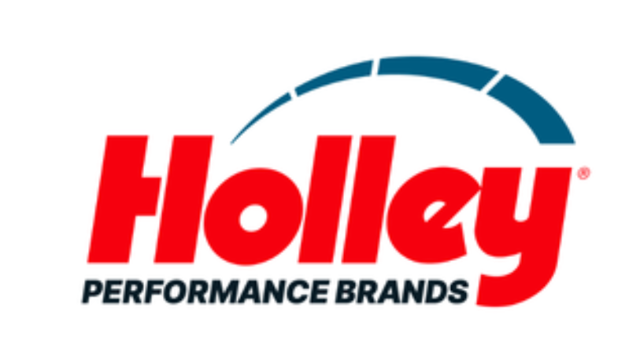

HOLLEY ACCELERATES DELEVERAGING WITH ANOTHER PROACTIVE PREPAYMENT OF DEBT, TOTALING $115 MILLION SINCE 2023
Holley Performance Brands continues balance sheet transformation with additional debt reduction, reinforcing financial flexibility and long-term value creation
NASHVILLE, TENN. – July 14, 2026 - Holley Performance Brands (NYSE: HLLY), home to a portfolio of iconic automotive brands serving enthusiasts across the high-performance aftermarket, today announced that it has made an additional $15 million voluntary prepayment of debt, further advancing its ongoing deleveraging strategy. With this incremental prepayment, the Company has now repaid $115 million of debt since September 2023, funded entirely with free cash flow. Cumulatively, the Company's debt reduction actions are expected to generate more than $4.5 million in annualized interest savings.
“Since Matthew Stevenson, President & CEO of Holley Performance Brands, and I joined in 2023, we are taking action to reduce net leverage from a peak of 5.67x to a targeted level below 3.5x by year-end, driven by significant operational improvements and consistent free cash flow generation,” said Jesse Weaver, Chief Financial Officer of Holley Performance Brands. “That progress reflects a disciplined, three-pronged capital allocation framework: reducing leverage, pursuing value-creating M&A, and returning capital to shareholders opportunistically. Today's prepayment advances the first of those priorities, and we remain committed to creating long-term value for shareholders through operational execution, prudent financial management, and continued deleveraging.”
The repayment was funded entirely through free cash flow and further reduces outstanding borrowings under the Company's debt facilities. As the Company continues to execute its strategic priorities, Holley expects ongoing debt reduction to support enhanced profitability, stronger cash flow conversion, and greater financial flexibility over time.
For more Holley company news, click here.
Exhibit 99.1

Forward-Looking Statements
Certain statements in this press release may be considered “forward-looking statements” within the meaning of the “safe harbor” provisions of the United States Private Securities Litigation Reform Act of 1995. Such forward-looking statements are subject to risks, uncertainties, and other important factors which could cause actual results to differ materially from those expressed or implied by such forward-looking statements, including but not limited to Holley’s ability to opportunistically reduce debt, complete accretive acquisitions of complementary brands at attractive valuations and opportunistically repurchase its own shares and the other risks and uncertainties set forth in the Annual Report on Form 10-K for the year ended December 31, 2025 filed with the U.S. Securities and Exchange Commission (“SEC”) on March 16, 2026, and in any subsequent filings with the SEC.

About Holley Performance Brands
Holley Performance Brands (NYSE: HLLY) is home to a portfolio of iconic brands that serve enthusiasts across the high-performance aftermarket. The company designs, engineers, manufactures and markets category-leading products and solutions for automotive enthusiasts through a focused portfolio spanning four consumer vertical groupings: American Performance, Modern Truck & Off-Road, Euro & Import, and Safety & Racing. For more than a century, Holley has built its reputation through innovation, technical expertise and a deep understanding of enthusiast culture. For more information, visit holley.com.

Investor Relations Contact(s):
Anthony Rozmus / Jenna Kozlowski
Solebury Strategic Communications
203-428-3224
Holley@soleburystrat.com

Media Relations Contact(s):
Nathan Espinosa/Michael Murray
Kahn Media
818-881-5246
Holley@KahnMedia.com

