UNITED STATES
SECURITIES AND EXCHANGE COMMISSION
Washington, D.C. 20549
FORM 8-K
CURRENT REPORT
PURSUANT TO SECTION 13 OR 15(d)
OF THE SECURITIES EXCHANGE ACT OF 1934
Date of Report (Date of earliest event reported): September 22, 2026
HOLLEY INC.
(Exact name of registrant as specified in its charter)
Delaware |  |  | 001-39599 |  |  | 87-1727560
(State or other jurisdiction  of incorporation) |  |  | (Commission  File Number) |  |  | (IRS Employer  Identification No.)
1A Burton Hills Blvd, Suite 240, Nashville, TN |  |  |  |  |  | 37215
(Address of principal executive offices) |  |  |  |  |  | (Zip Code)
(270) 782-2900
(Registrant’s telephone number, including area code)
(Former name or former address, if changed since last report)
Check the appropriate box below if the Form 8-K is intended to simultaneously satisfy the filing obligation of the registrant under any of the following provisions:
o |  |  | Written communications pursuant to Rule 425 under the Securities Act (17 CFR 230.425)
o |  |  | Soliciting material pursuant to Rule 14a-12 under the Exchange Act (17 CFR 240.14a-12)
o |  |  | Pre-commencement communications pursuant to Rule 14d-2(b) under the Exchange Act (17 CFR 240.14d-2(b))
o |  |  | Pre-commencement communications pursuant to Rule 13e-4(c) under the Exchange Act (17 CFR 240.13e-4(c))
Securities registered pursuant to Section 12(b) of the Act:
Title of each class |  |  |  |  |  | Trading  Symbol(s) |  |  |  |  |  | Name of each exchange  on which registered
Common stock, par value $0.0001 per share |  |  |  |  |  | HLLY |  |  |  |  |  | New York Stock Exchange
Indicate by check mark whether the registrant is an emerging growth company as defined in Rule 405 of the Securities Act of 1933 (§230.405 of this chapter) or Rule 12b-2 of the Securities Exchange Act of 1934 (§240.12b-2 of this chapter).
Emerging growth company o
If an emerging growth company, indicate by check mark if the registrant has elected not to use the extended transition period for complying with any new or revised financial accounting standards provided pursuant to Section 13(a) of the Exchange Act. o

Item 8.01 Other Events.
On September 22, 2026, the Company made a voluntary prepayment of $10 million of outstanding principal under its first lien term loan facility. On September 23, 2026, the Company issued a press release announcing the prepayment. A copy of the press release is attached hereto as Exhibit 99.1 and incorporated herein by reference.

Item 9.01 Financial Statements and Exhibits.
(d) Exhibits
Exhibit  No. |  |  |  |  |  | Description
99.1 |  |  |  |  |  | Press Release, dated September 23, 2026
104 |  |  |  |  |  | Cover Page Interactive Data File (formatted as Inline XBRL).

SIGNATURES
Pursuant to the requirements of the Securities Exchange Act of 1934, the registrant has duly caused this report to be signed on its behalf by the undersigned hereunto duly authorized.
 |  |  | HOLLEY INC.
 |  |  | By: |  |  | /s/ Jesse Weaver
 |  |  |  |  |  | Name: Jesse Weaver
Date: September 23, 2026 |  |  |  |  |  | Title: Chief Financial Officer

Exhibit 99.1

PRESS RELEASE

1A Burton Hills Blvd., Suite 240
Nashville, TN 37215
Holley.com
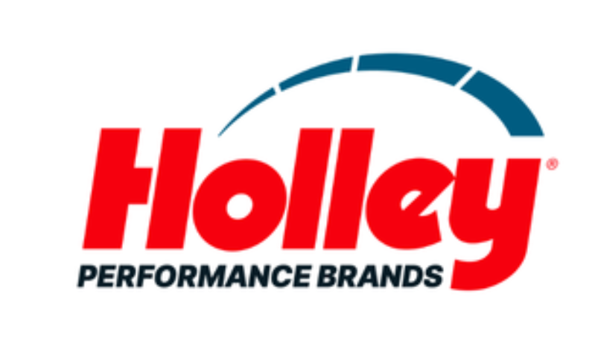

HOLLEY CONTINUES DELEVERAGING WITH ADDITIONAL DEBT PREPAYMENT, TOTAL REPAYMENTS REACH $125 MILLION SINCE 2023
Latest prepayment continues Holley's deleveraging trajectory for the last three years and reinforces the Company's long-term goal to be at or below 3.0x leverage.
NASHVILLE, TENN. – September 23, 2026 - Holley Performance Brands (NYSE: HLLY), a leader in automotive aftermarket performance solutions, today announced a voluntary prepayment of $10 million toward its term loan, reflecting the Company’s continued focus on balance sheet optimization and disciplined capital deployment.
Including this latest payment, Holley has repaid a total of $125 million of debt since September 2023, funded entirely through free cash flow generation. Since initiating this program, the Company has reduced its Total Leverage Ratio from a peak of 5.67x, remains on track to reach its previously communicated year-end target of below 3.5x, and continues to target a long-term leverage ratio of approximately 3.0x. Cumulatively, the $125 million in debt reductions generate approximately $5 million in annualized net interest savings.
“This latest prepayment reflects the discipline and consistency of our capital allocation approach,” said Jesse Weaver, Chief Financial Officer of Holley Performance Brands. “Since 2023, we have reduced our debt by $125 million, funded entirely by free cash flow, while continuing to invest in the business. That progress reflects our three-pronged capital allocation framework: reducing leverage, pursuing accretive M&A, and returning capital to shareholders opportunistically. We remain on track to bring year-end leverage below 3.5x, with a long-term target of approximately 3.0x, and we believe this continued financial discipline positions Holley to create long-term value for our shareholders.”
For more Holley company news, click here.
Forward-Looking Statements
Exhibit 99.1

Certain statements in this press release may be considered “forward-looking statements” within the meaning of the “safe harbor” provisions of the United States Private Securities Litigation Reform Act of 1995. Such forward-looking statements are subject to risks, uncertainties, and other important factors which could cause actual results to differ materially from those expressed or implied by such forward-looking statements, including but not limited to Holley’s ability to achieve its stated leverage targets, opportunistically reduce debt, complete accretive acquisitions of complementary brands at attractive valuations, and opportunistically repurchase its own shares, and the other risks and uncertainties set forth in the Annual Report on Form 10-K for the year ended December 31, 2025 filed with the U.S. Securities and Exchange Commission (“SEC”) on March 16, 2026, and in any subsequent filings with the SEC.

About Holley Performance Brands
Holley Performance Brands (NYSE: HLLY) is home to a portfolio of iconic brands that serve enthusiasts across the high-performance aftermarket. The company designs, engineers, manufactures and markets category-leading products and solutions for automotive enthusiasts through a focused portfolio spanning four consumer vertical groupings: American Performance, Modern Truck & Off-Road, Euro & Import, and Safety & Racing. For more than a century, Holley has built its reputation through innovation, technical expertise and a deep understanding of enthusiast culture. For more information, visit https://www.holley.com.

Investor Relations Contact(s):
Anthony Rozmus / Jenna Kozlowski
Solebury Strategic Communications
203-428-3224
Holley@soleburystrat.com

Media Relations Contact(s):
Nathan Espinosa/Michael Murray
Kahn Media
818-881-5246
Holley@KahnMedia.com

